Steps to Configure and Run Jmeter on TeamCity.

Step1 : Download Jmeter and configure as per mentioned notes

<https://devblog.xero.com/run-jmeter-performance-tests-on-teamcity-8315f7ccffc1>

* Download the addon and navigate to Admin -> Plugins -> Upload the zip file

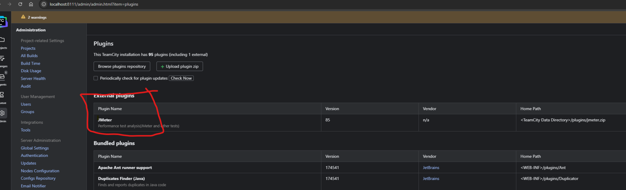

* Set environment variable path to jmeter installation . so that jmeter command can be executed by TeamCity

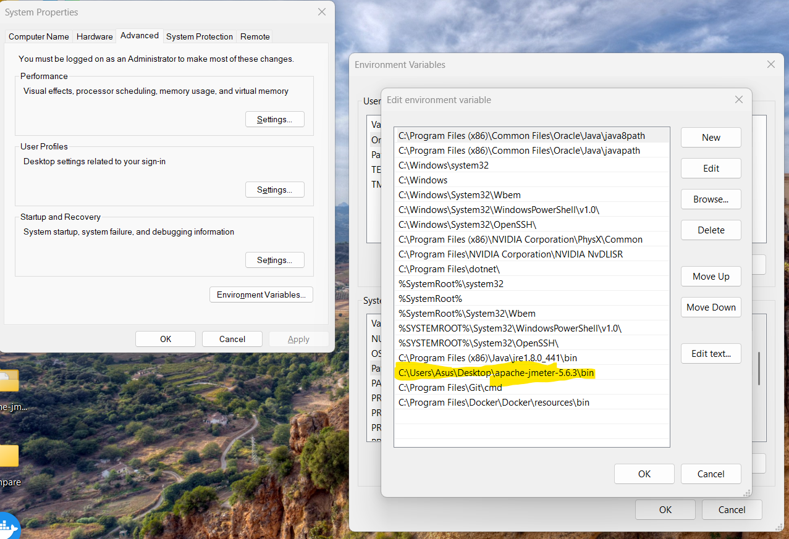

Step 2 : Configure TeamCity to run on URL

<http://localhost:8111/>

Step 3 : Create a new TeamCity project and define following parameters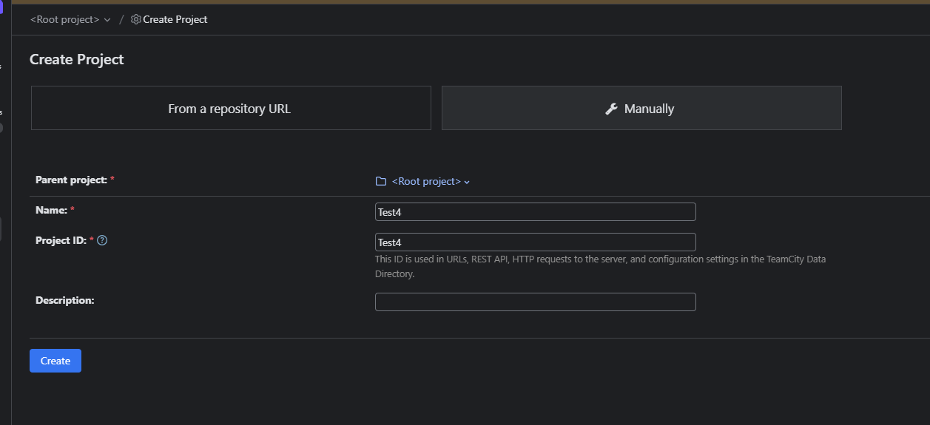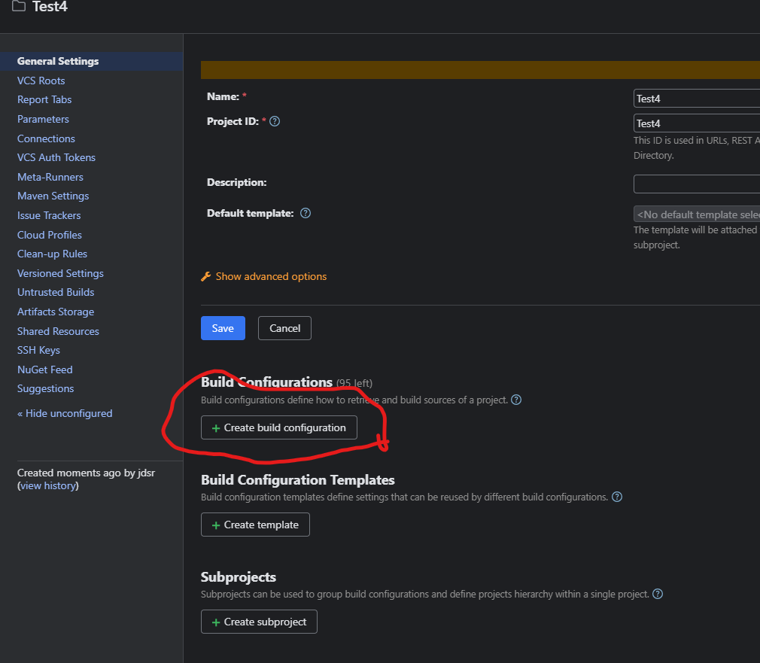

Add a Build Step : Create Build Configuration

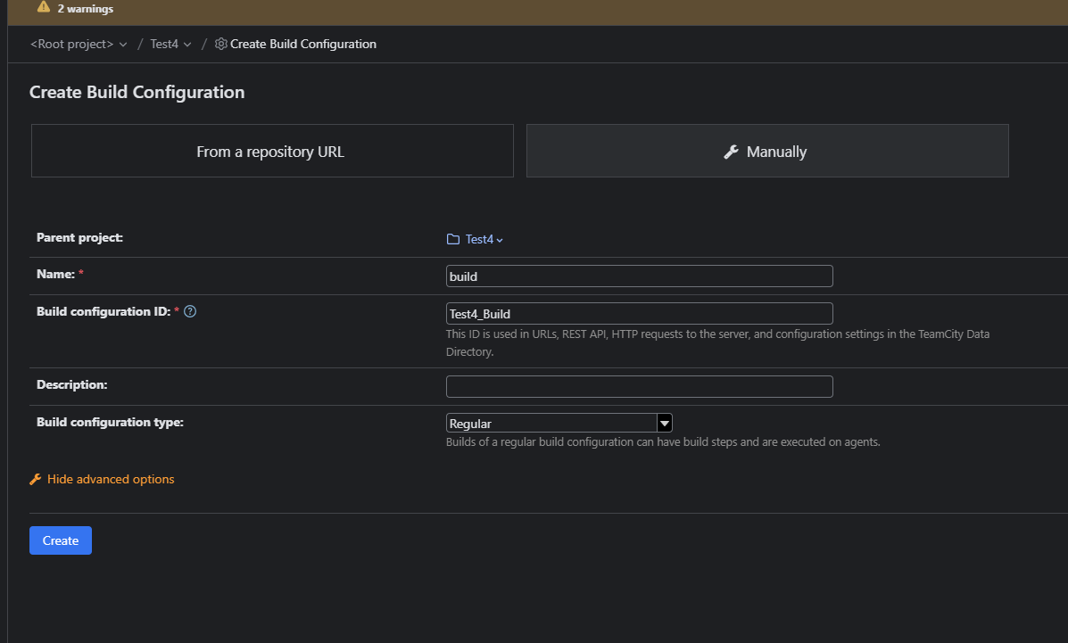

Skip this step :

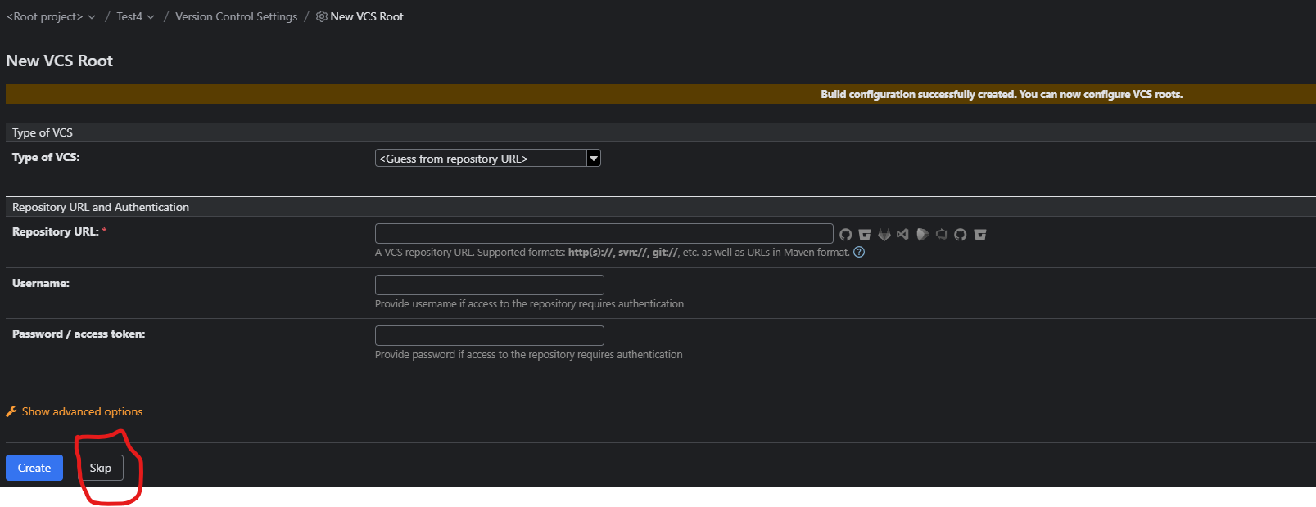

Add a build Step

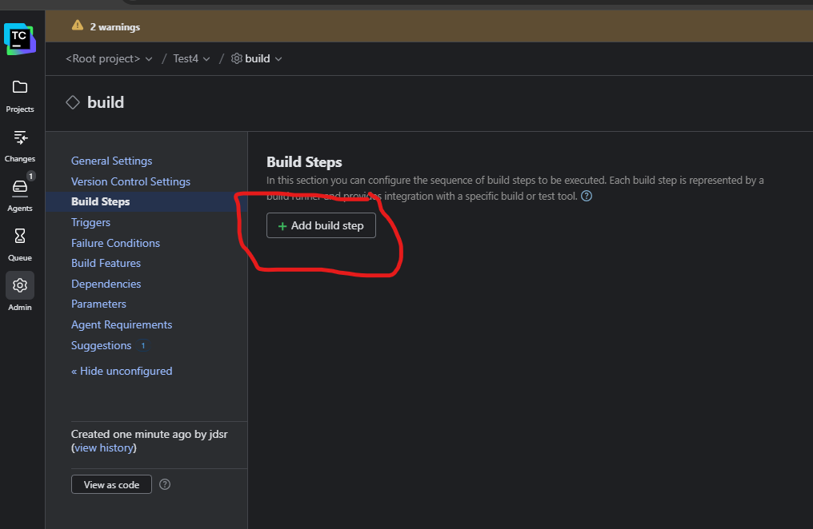

Select Command Line

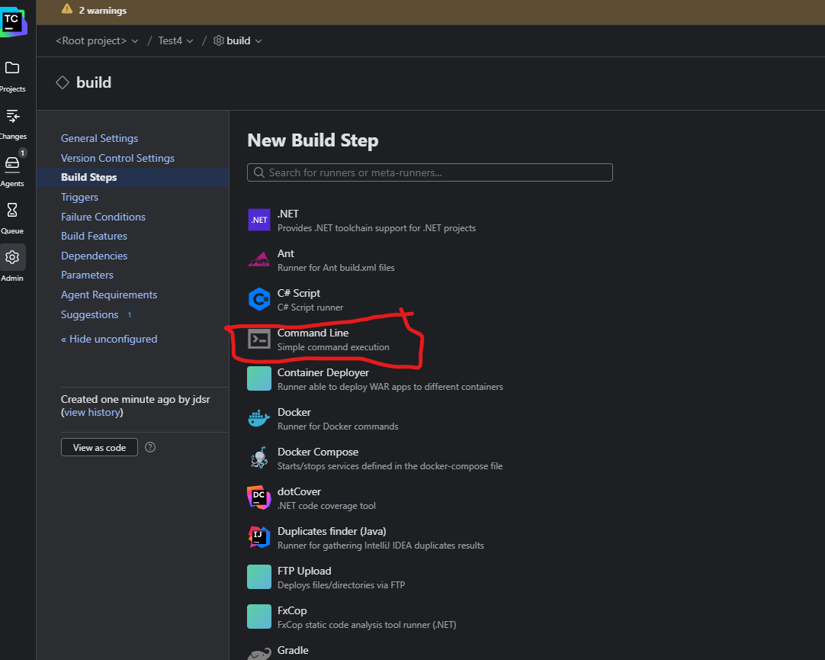

Select Custom script and provide following input

//This command is to execute jmeter in non JUI Mode and generate an output report which we will email.

jmeter -n -t %Param_FilePath%\%Script_Name% -l%jmeter_logfile% -j %Param_FilePath%\jmeter_Run%build.counter%.log -e -o %Param_FilePath%\report_Run%build.counter%

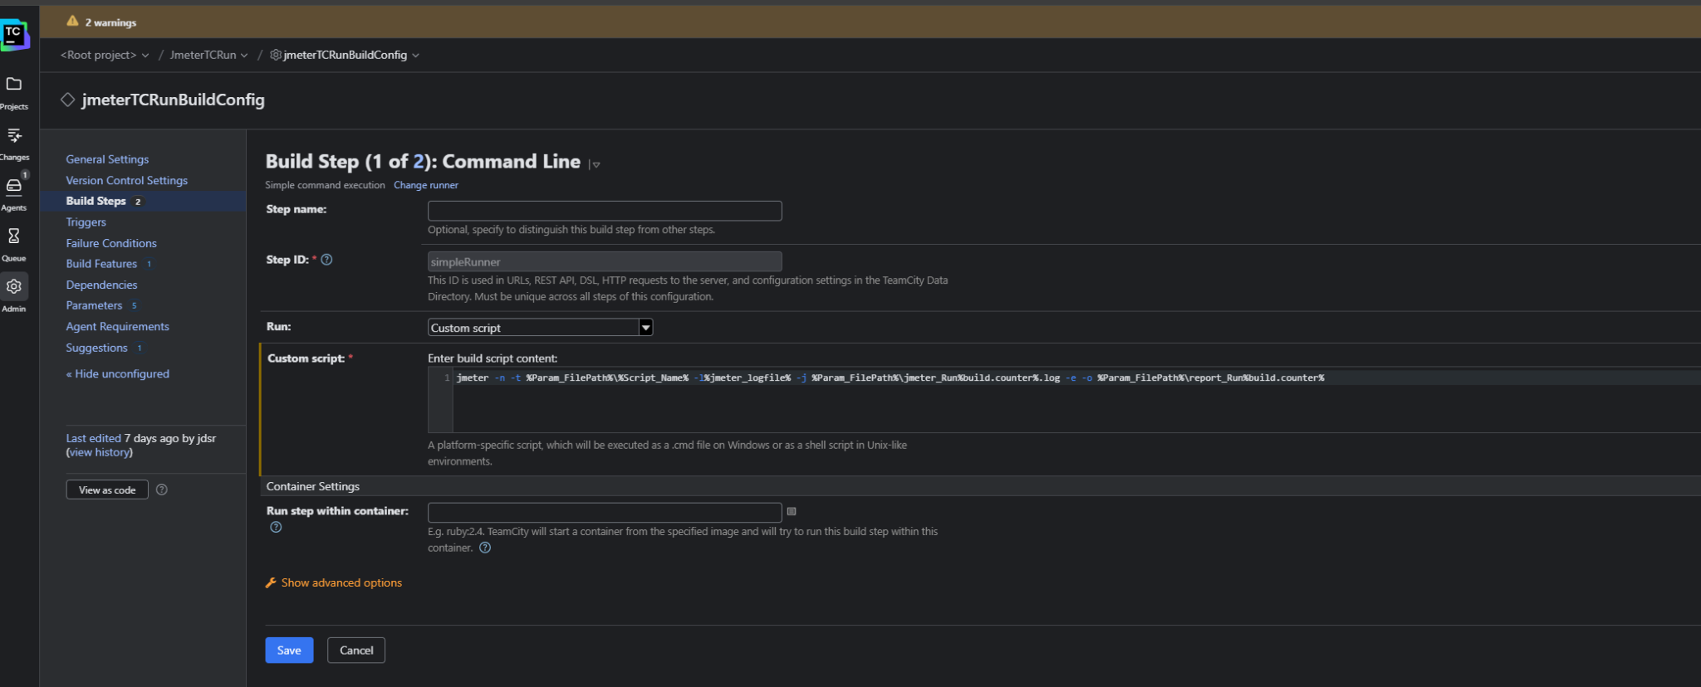

Add another build step : Power shell and provide following code

// This code is to send the report through email

$SMTPServer = "smtp.gmail.com" # Change if using another email provider

$SMTPPort = "587"

$Username = "jaideep.rathore@gmail.com" # Your configured email in TeamCity

$Password = "lrkd sssf joga idrw" # Use an App Password instead of your regular password

$From = "jaideep.rathore@gmail.com"

$To = "jaideep.rathore@gmail.com" # The recipient

<#

$To = @(

"jaideep.rathore@gmail.com",

"recipient1@example.com",

"recipient2@example.com",

"recipient3@example.com",

"recipient4@example.com"

)

#>

$Subject = "JMeter Test Report - Build %teamcity.build.number%"

$Body = "Attached is the latest JMeter test report for build %teamcity.build.number%."

# Path to the artifact (Ensure this is the correct path!)

$BuildCounter = "${env:BUILD_NUMBER}" # Fetch the build number dynamically

$Attachment = "%Param_FilePath%\report.zip"

# Convert password to Secure String

$SecurePassword = ConvertTo-SecureString $Password -AsPlainText -Force

$Credential = New-Object System.Management.Automation.PSCredential ($Username, $SecurePassword)

# Send Email with Attachment

Send-MailMessage -From $From -To $To -Subject $Subject -Body $Body -SmtpServer $SMTPServer -Port $SMTPPort -Credential $Credential -UseSsl -Attachments $Attachment

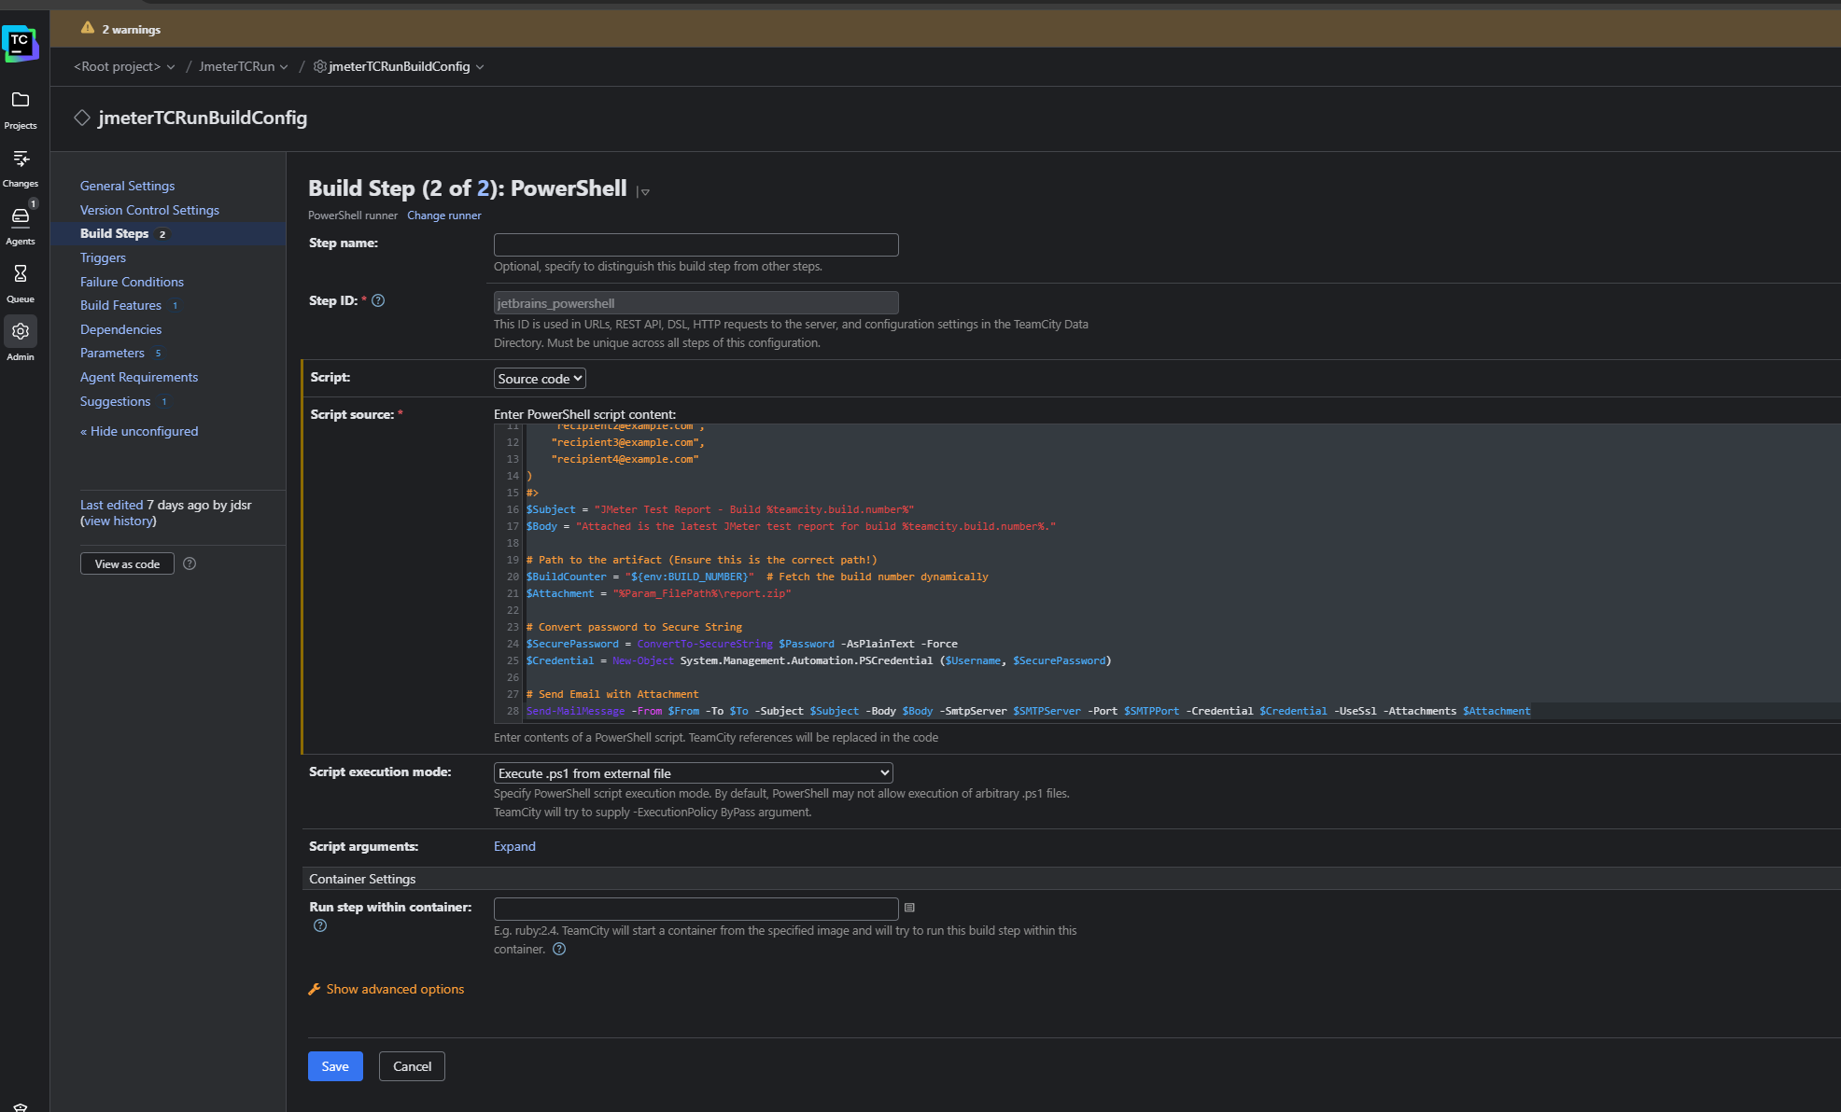

Navigate to project level and create following parameters

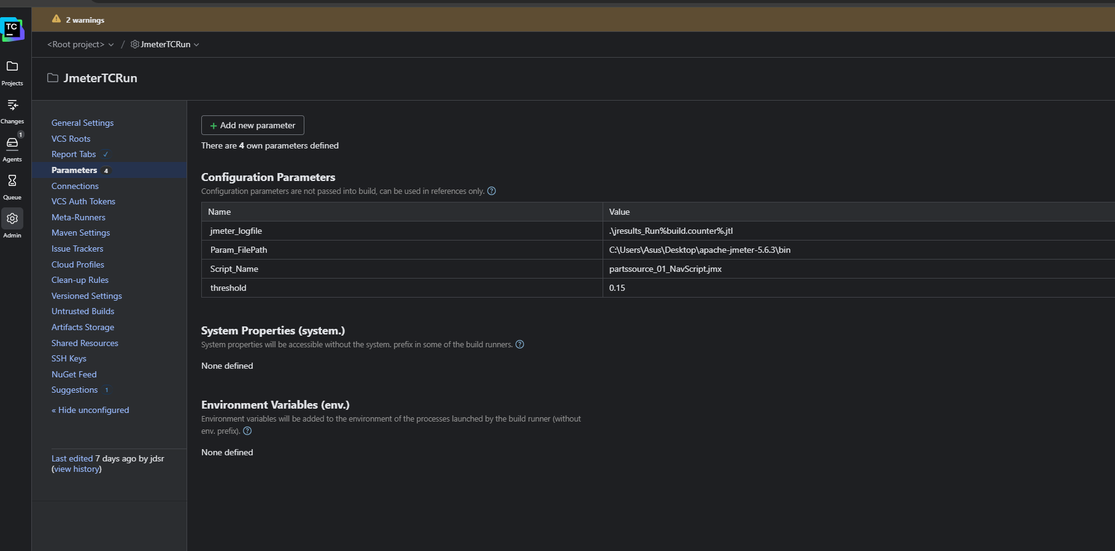

| Name | Value |
| --- | --- |
| **jmeter_logfile** | **.\jresults_Run%build.counter%.jtl** |
| **Param_FilePath** | **C:\Users\Asus\Desktop\apache-jmeter-5.6.3\bin** |
| **Script_Name** | **partssource_01_NavScript.jmx** |
| **threshold** | **0.15** |

**Jmeter_logfile : This is the jmeter log file that we are storing at an internal location so that it can be picked by Addon.**

**Param_FilePath : This is the location of jmeter extraction**

**Script_Name : Script to be executed**

**Threshold : This value is used by addon to generate a comparative report**

**Under Build Feature : Add a build feature**

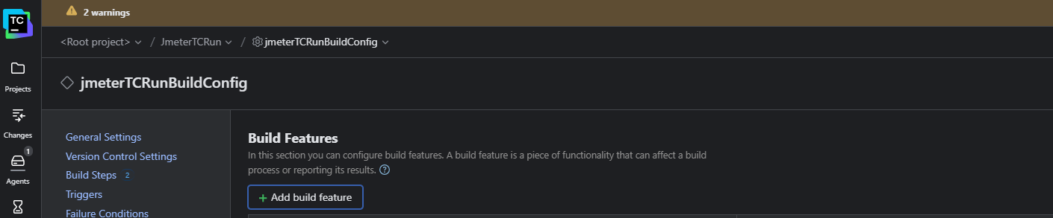

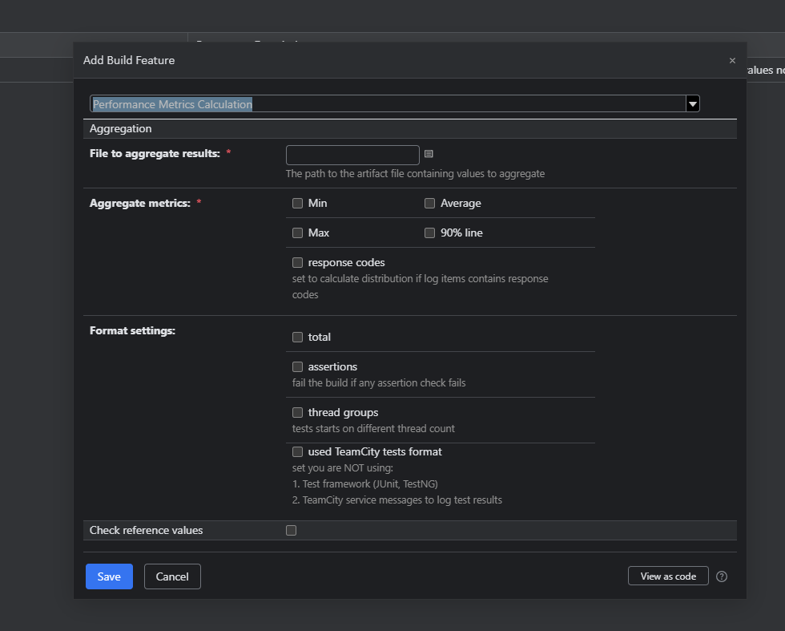

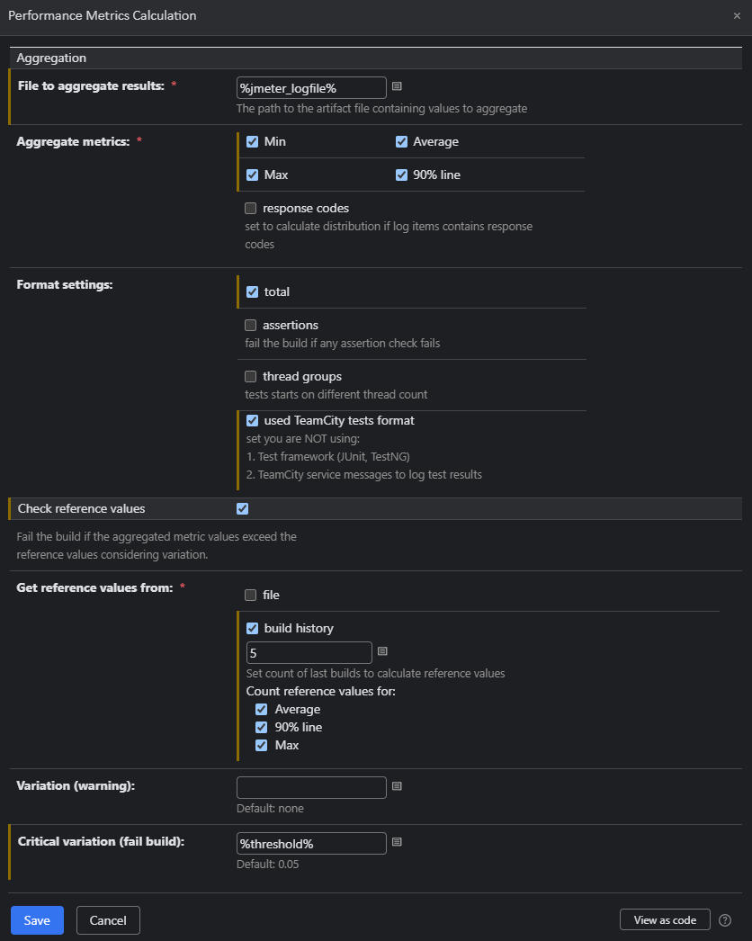

**// This helps us generate the comparative report through addon**

**In Build Configuration : Provide following in Artifact path . This is required to push the jmeterlog file and report zip file as an artifact**

**%jmeter_logfile%**

**%Param_FilePath%\jmeter_Run%build.counter%.log**

**%Param_FilePath%\report_Run%build.counter%/** => report.zip**

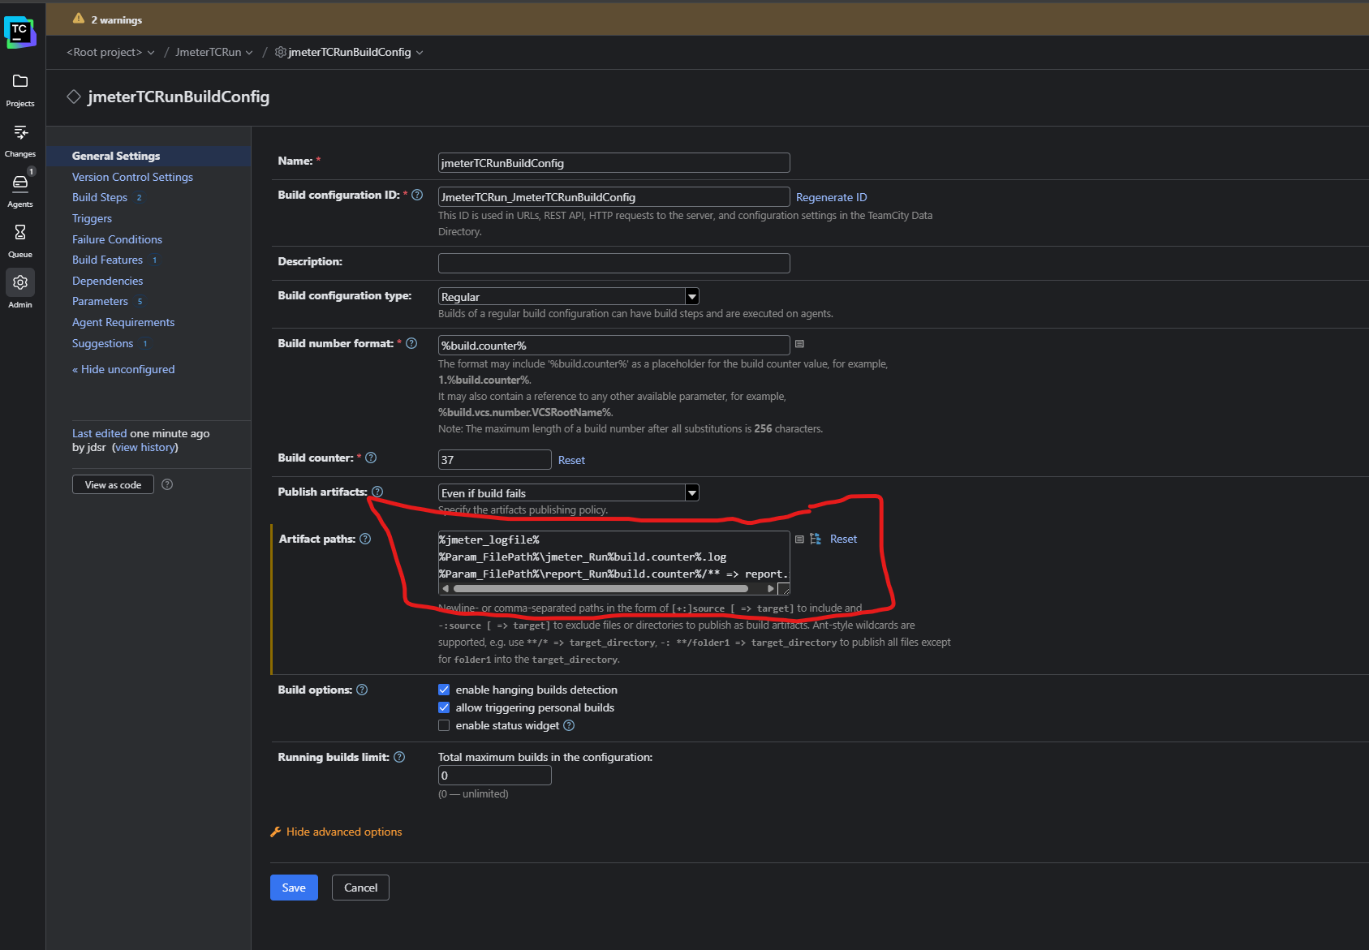

**Execute the Build :**

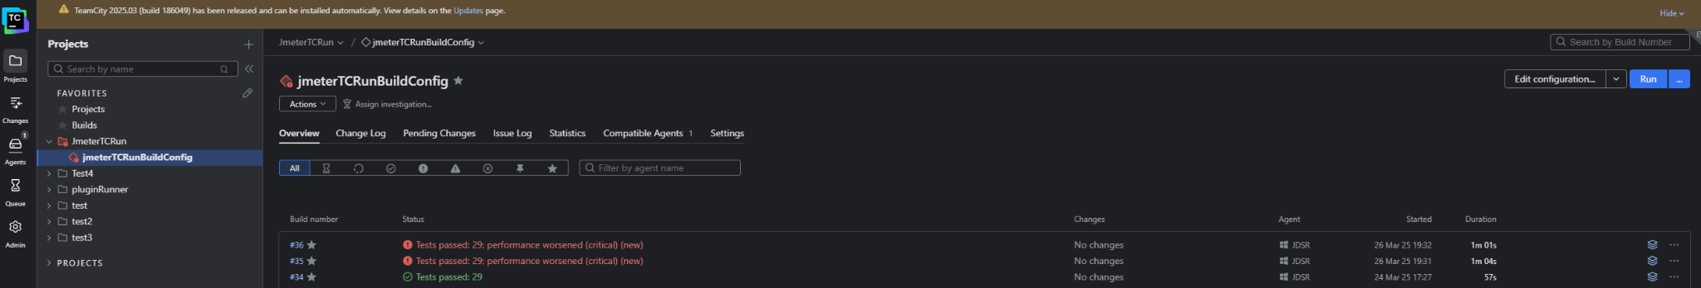

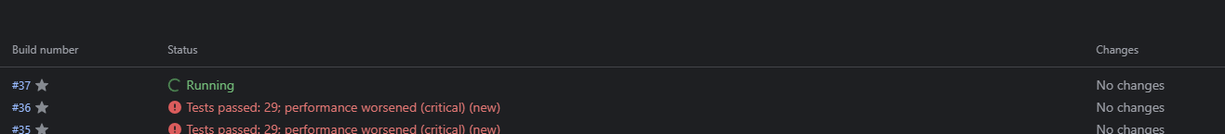

**We can see build logs for current progress**

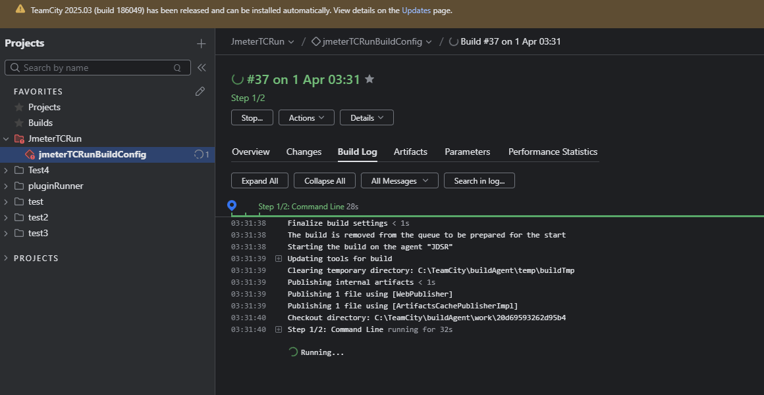

**After execution note the JmeterLog File , JTL File and Report file is generated in artifacts**

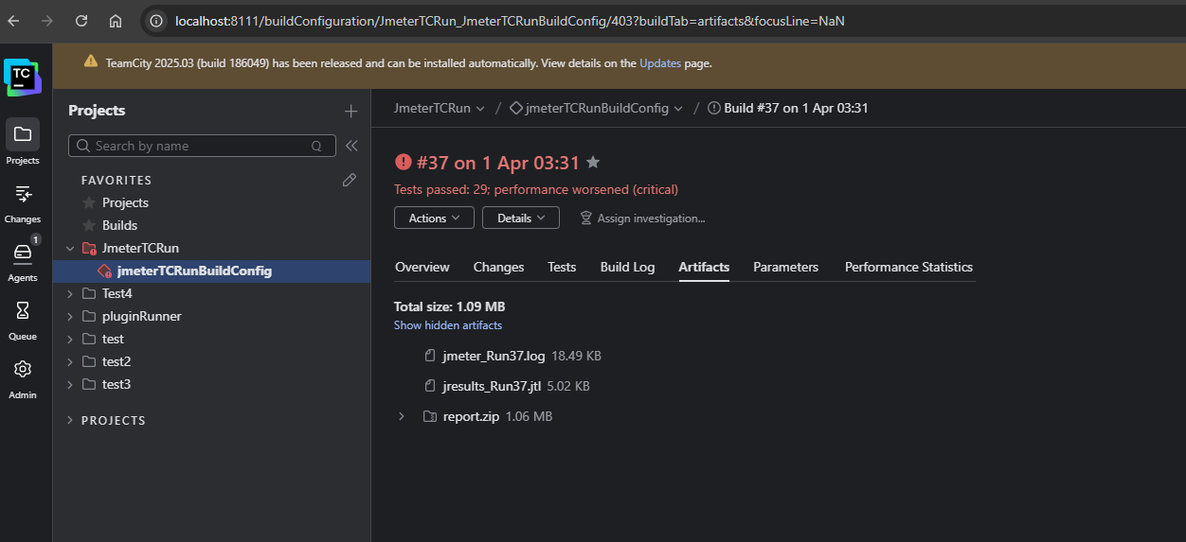

**Note that you will get an email at specified address with attched HTML report**

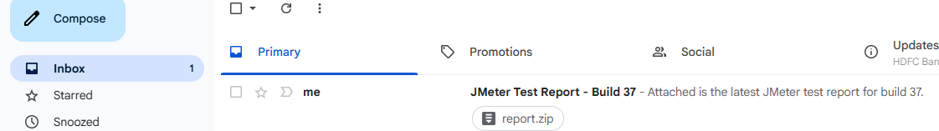

**Under Performance statistics tab , we get a report with comparison from the previous run**

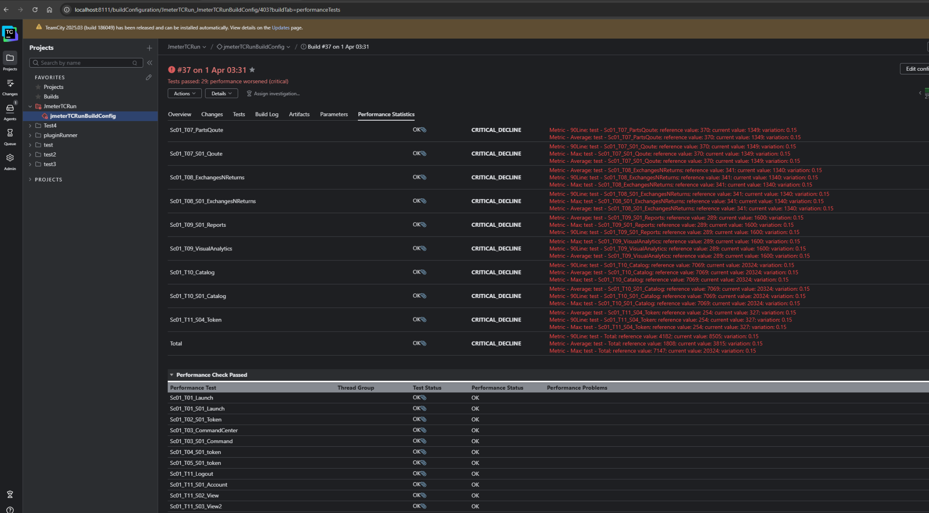

**Also note that you can find HTML report in BIN folder**

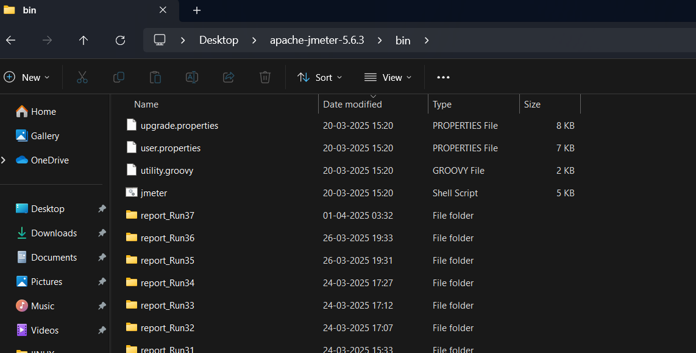

**HTML Report contains summary of the run**

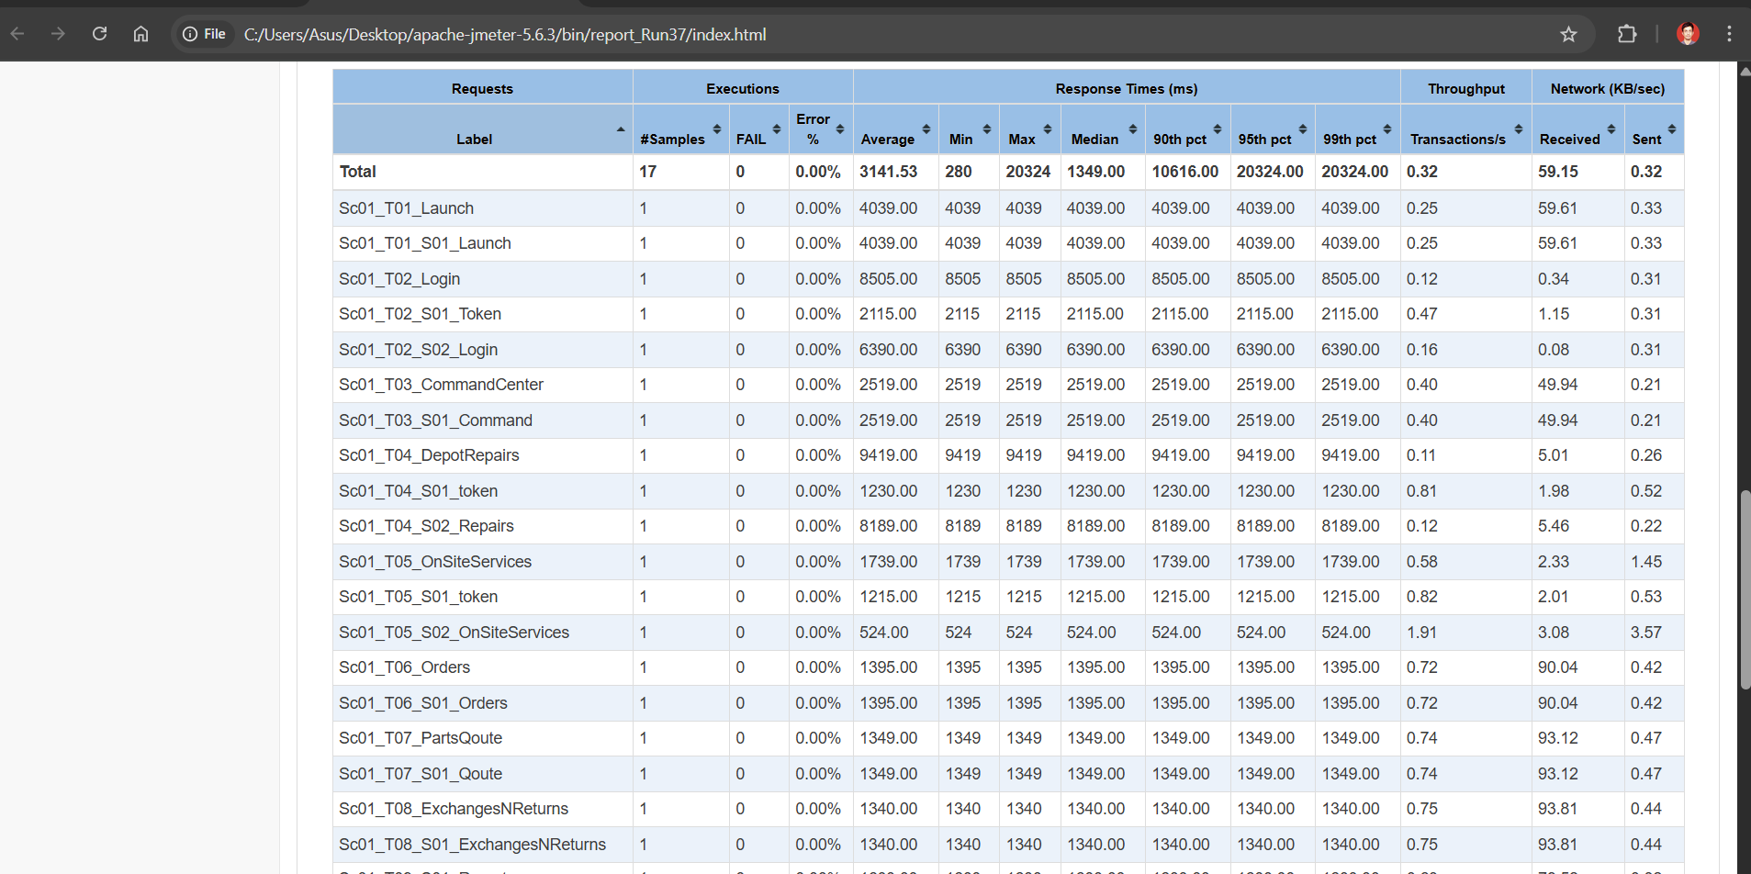

**Add Trigger : To Enable the execute automatically every 10 Mins**

